Create your first SRDF App

1. First Create a Visual Studio Application

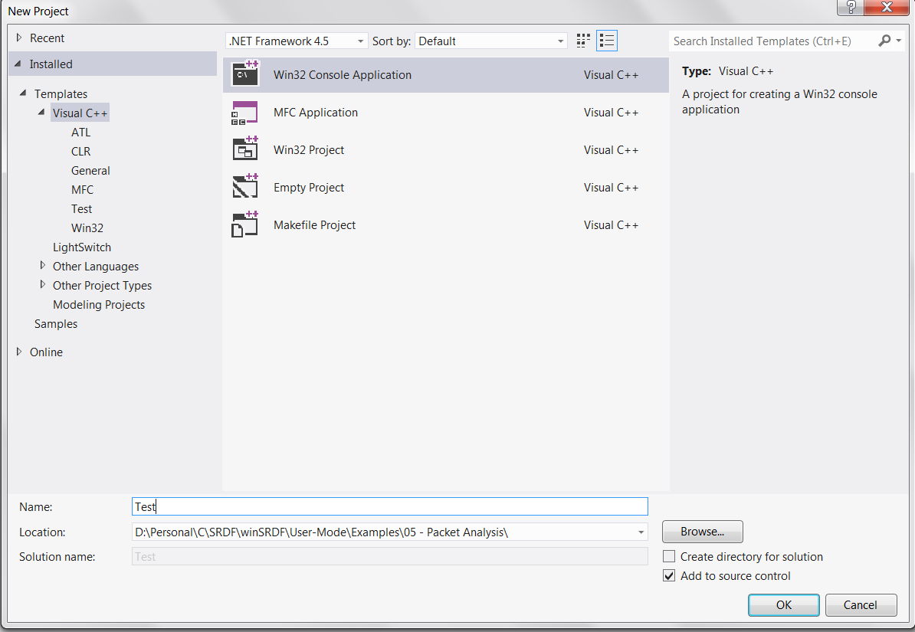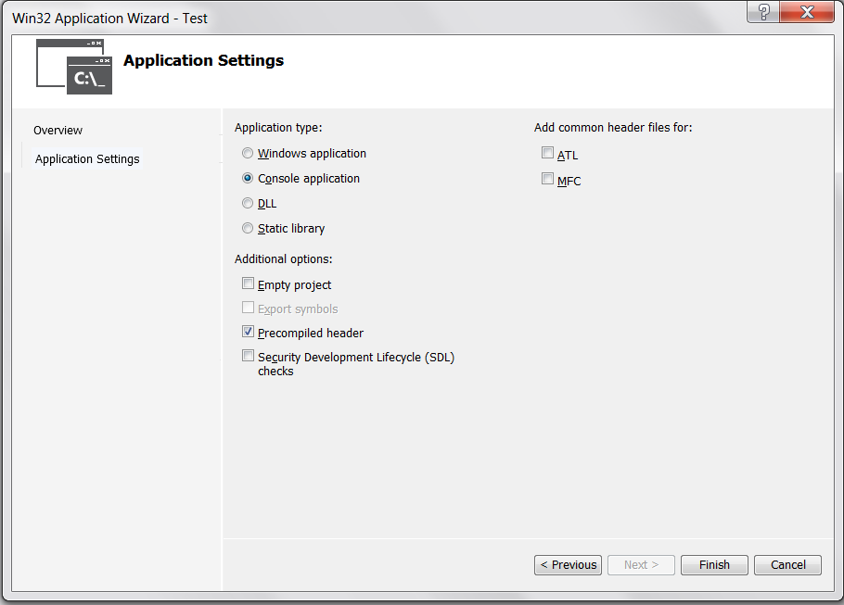

1. Add SRDF Project
2. Change the project settings from unicode to ascii.  
   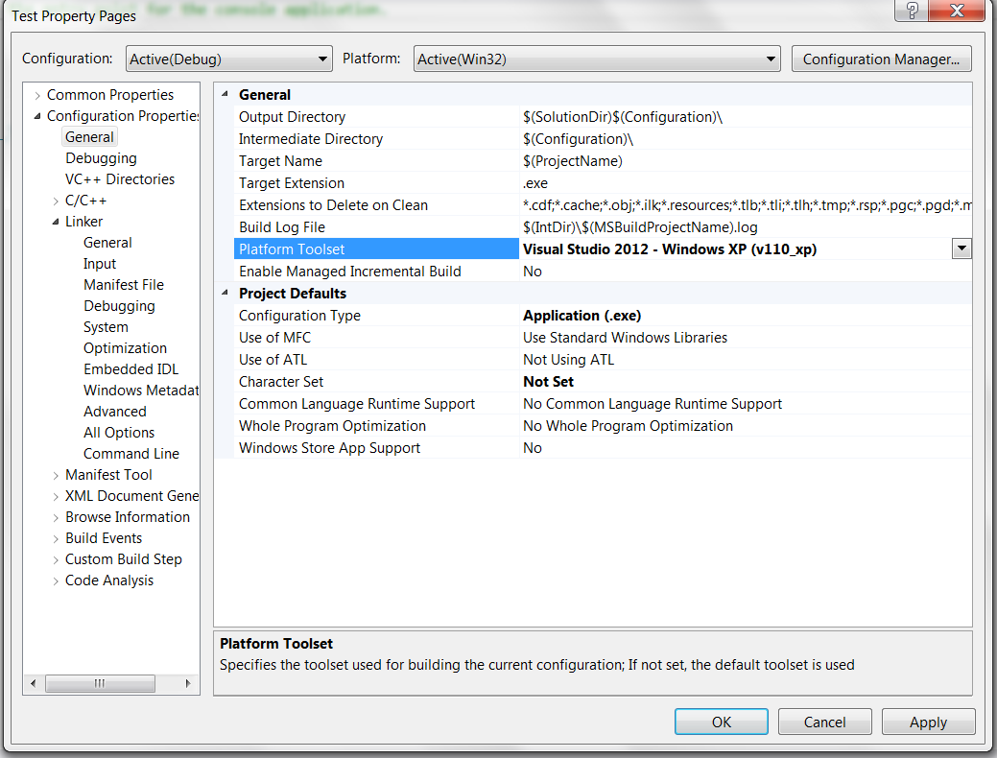
3. Add SRDF.lib to the linker input

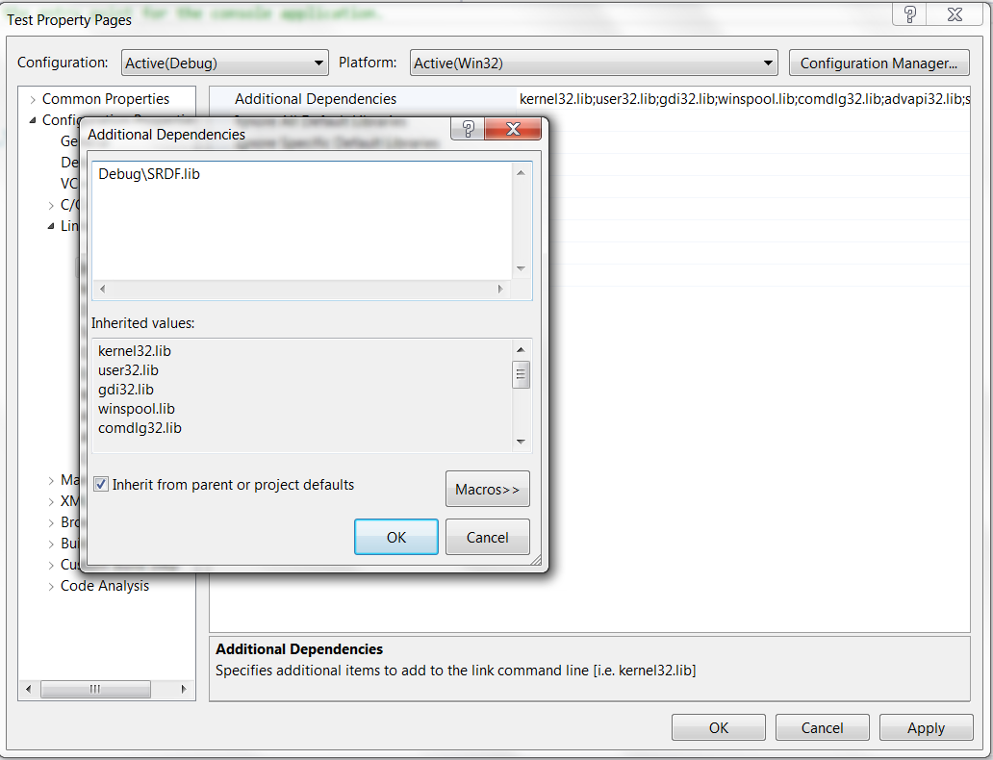

6. Add "#define WIN32_LEAN_AND_MEAN" to stdafx.h  
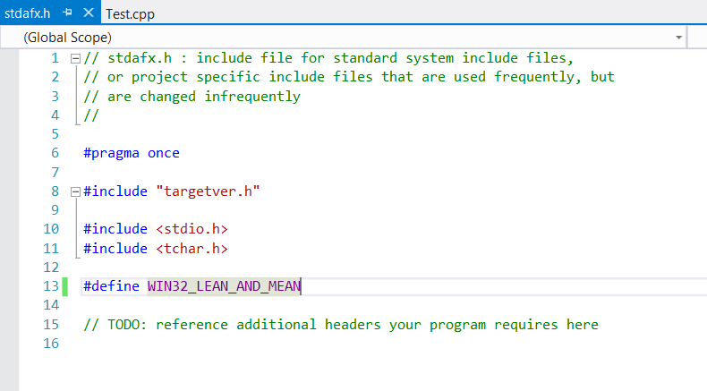

7. Copy "x86 Emulator.dll" and "sqlite3.dll"

8. include SRDF.h file and all includes folder

